TASK 1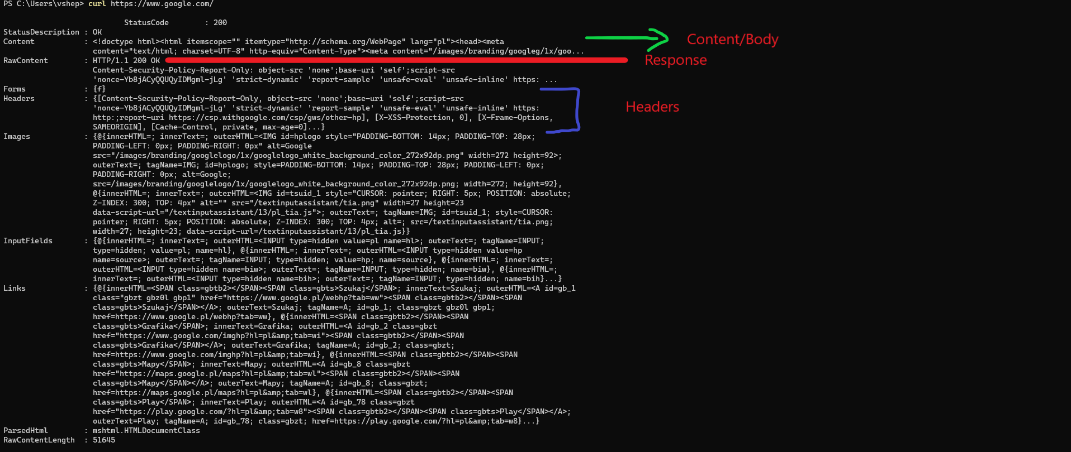

TASK 2

TASK 3

<https://www.google.com/search?q=cats> (cats is new query string entered from the keyboard)

TASK 4

Here the form is used and method = “post”

TASK 5

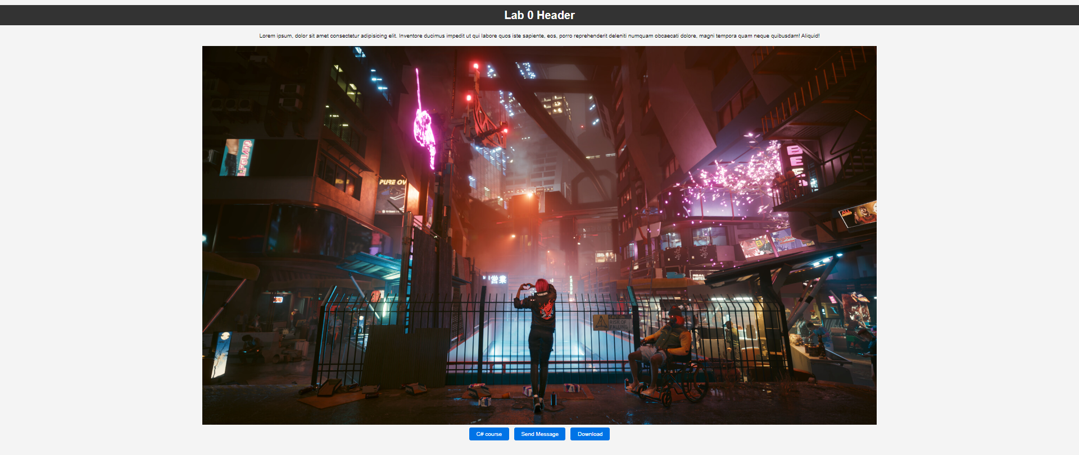

<!DOCTYPE html>

<html lang="en">

<head>

    <meta charset="UTF-8">

    <meta name="viewport" content="width=device-width, initial-scale=1.0">

    <title>LAB 0</title>

    <style>

        body {

            font-family: 'Arial', sans-serif;

            background-color: #f4f4f4;

            margin: 0;

            padding: 0;

            text-align: center;

        }

        h1 {

            background-color: #333;

            color: #fff;

            padding: 10px;

        }

        p {

            margin: 20px;

        }

        a {

            text-decoration: none;

            color: #0073e6;

        }

        a:hover {

            text-decoration: underline;

        }

        img {

            max-width: 100%;

            height: auto;

        }

        .button {

            display: inline-block;

            padding: 10px 20px;

            background-color: #0073e6;

            color: #fff;

            border: none;

            border-radius: 5px;

            text-decoration: none;

            margin: 5px;

        }

    </style>

</head>

<body>

    <h1>Lab 0 Header</h1>

    <p>Lorem ipsum, dolor sit amet consectetur adipisicing elit. Inventore ducimus impedit ut qui labore quos iste sapiente, eos, porro reprehenderit deleniti numquam obcaecati dolore, magni tempora quam neque quibusdam! Aliquid!</p>

    <!-- This is some comment -->

    <a href="https://www.youtube.com/watch?v=KvMY1uzSC1E&ab_channel=Netflix" target="_blank">

        <img src="https://cdn.akamai.steamstatic.com/steam/apps/1091500/ss_b529b0abc43f55fc23fe8058eddb6e37c9629a6a.1920x1080.jpg?t=1695308476" alt="Cyberpunk image">

    </a>

    <br>

    <a href="https://www.youtube.com/watch?v=dQw4w9WgXcQ&ab_channel=RickAstley" target="_blank" class="button">C# course</a>

    <a href="mailto:email@address.com" class="button">Send Message</a>

    <a href="codes.zip" download="Download files" class="button">Download</a>

</body>

</html>

TASK 6

